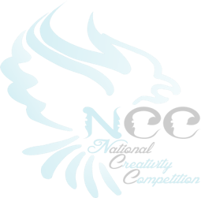
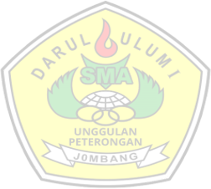
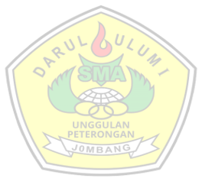

JUKNIS SPEECH CONTEST NCC 13Th

SMA DARUL ULUM 1 PETERONGAN JOMBANG

THEME
“EMPOWERING AN INTEGRATED, ADAPTIVE, AND INNOVATIVE YOUTH TO FACE CHALLENGES AND LEAD CHANGE WITHIN A CIVIL SOCIETY ROOTED IN NOBLE CHARACTERS”

SUB THEME
“Building Integrity Among the Younger Generation Amidst a Culture of Instant Gratification and Shortcuts”

ADMINISTRATION REQUIREMENTS
  - The competition is for individual participants.
  - Participants must be Junior High School students (SMP/MTs).
  - Enrollment status must be proven by submitting a scanned copy/photo of a student identity card or a certificate of active enrollment signed by the School Principal.
  - Each participant must be guided by one supervisor/coach from the same school.
  - The submitted work must be original and has never been published and has never won any competition and is not in the process of another competition.
  - The originality form must be signed over an IDR 10,000 duty stamp (materai).
  - The NCC 13th speech contest is opened only to participants who have never won first place in previous NCC competitions within the same category.

TIMELINE

First Stage of Wave I

Date | Mechanism
16 June – 22 August 2026 | Registration and Deadline of First Wave: Submission of speech drafts on NCC 13ᵗʰ website (23:59 WIB)
3 September 2026 | first wave selection results announcement

First Stage of Wave II

Date | Mechanism
1 October - 25 October 2026 | Registration and Deadline of Second Wave: Submission of speech drafts via NCC 13ᵗʰ website (23:59 WIB)
14 November 2026 | second wave selection results announcement (16:00 WIB)
23 November 2026 | Technical Meeting for Wave I and Wave II Semifinalists (10:30 WIB)
24 November – 30 November 2026 | Payment and Deadline of Second stage: Submission of video speeches of the semifinalists selected from the first stage will be uploaded to Google Drive and send to the website of NCC 13th
07 December 2026 | Speech Finalist Announcement (16:00 WIB)

NCC 13th (National Creativity Competition) 2026-2027 |33


10 December 2026 | Online Technical Meeting (Via Zoom Meeting) (10.30 WIB)
17 December 2026 | Deadline for Attendance Confirmation (00:00-23:59 WIB)
12 January 2027 | One-Site Registration at SMA DARUL ULUM 1 PETERONGAN (06:00-07:00 WIB)
12 January 2027 | Final Stage: Speech Delivery and Problem Solving
13 January 2027 | Winners Announcement

REGISTRATION MECHANISM
  - Each participant must register their own account through the NCC 13th website: https://national-creativty-competition.vercel.app/
  - Operators can register participants for their respective competitions.
  - The registration tutorial is available on the NCC 13th website. To register, go to https://national-creativty-competition.vercel.app/, fill out the form, and click “Register Now”.
  - Registration for Wave I and Wave II of the NCC 13th Speech Contest is free.
  - The registration fee for the 2nd stage is Rp50.000,00. Payment for the NCC 13th Speech Contest can be made via: Bank BSI Account Number: 7728828883 (nccsmadu1)
  - Participants must follow the official Instagram accounts of the NCC 13th: @nccsmadu1 and @hitsdarululum1. Additionally, they must upload the NCC 13th Science and Olympiad competition poster to their Instagram and tag the official accounts and SMA DARUL ULUM 1 PETERONGAN accounts.
  - Participants are required to upload the Twibbon provided via the link https://national-creativty-competition.vercel.app/
  - Participants are prohibited from using private social media accounts.
  - Participants submit originality statement forms of their work and manuscripts via the NCC 13th website https://national-creativty-competition.vercel.app/
  - The quota of participants per school is unlimited.
  - Participants from Wave I who did not pass the Stage 1 selection may re-register and participate in the Stage 1 Wave II selection.

COMPETITION TECHNICAL GUIDELINES

Stage 1 (Selection Round)
    - Wave I
      - Participants must register via: https://national-creativty-competition.vercel.app/.
      - The deadline for registration and manuscript submission is Saturday, August 22nd, 2026, at 23:59 WIB.
      - Participants must submit a speech draft related to the theme of the NCC 13th. The draft must be submitted as a soft copy.
      - The soft copy must be uploaded to https://ncc-smadu1.com/ with the following file name format: NCC13TH_SPEECHCONTEST_ STAGE1 (full name) (school name)
Example: NCC13TH_SPEECHCONTEST_ STAGE1_TSALISA

NCC 13th (National Creativity Competition) 2026-2027 |34

NAJMA_SMP PELITA HARAPAN.

      - The Stage 1 selection results will be announced on Thursday, September 3rd, 2026, via https://national-creativty-competition.vercel.app/ and Instagram at @nccsmadu1.
      - To pass the first stage, participants must achieve a minimum score of 75.
      - Participants who pass the first stage must pay a registration fee of IDR 50,000, in accordance with the stated provisions. The fee must be paid via Bank BSI, Account number: 7728828883 (nccsmadu1).

Wave II
      - Participants must register via: https://national-creativty-competition.vercel.app/
      - The deadline for registration and manuscript submission is Sunday, October 25th, 2026, at 23:59 WIB.
      - Participants must submit a speech draft related to the theme of the NCC 13th. The draft must be submitted as a soft copy.
      - The soft copy must be uploaded to https://ncc-smadu1.com/ with the following file name format: NCC13TH_SPEECHCONTEST_ STAGE1_(full name)_(school name)
Example: NCC13TH_SPEECHCONTEST_ STAGE1_TSALISA NAJMA_SMP PELITA HARAPAN.
      - The Stage 1 selection results will be announced on Saturday, November 14th, 2026, via https://national-creativty-competition.vercel.app/and Instagram at @nccsmadu1.
      - To pass the first stage, participants must achieve a minimum score of 75.
      - Participants who pass the first stage must pay a registration fee of IDR 50,000, in accordance with the stated provisions. The fee must be paid via Bank BSI, Account number: 7728828883 (nccsmadu1).

Stage 2 (Semifinal Round)
    - Participants who pass the first stage (Wave I and Wave II) as semifinalists must submit a video of their speech delivery. Semifinalists must also ensure they have joined the semifinal WhatsApp group
    - Semifinalists must ensure they have completed the Stage 2 registration by uploading their proof of payment to the NCC 13th website.
    - The Technical Meeting for the Second Stage Selection will be held on Monday,
November 23rd, 2026, at 10:30 WIB via Zoom Meeting
    - The submission deadline for the videos is Monday, November 30th, 2026.
    - The video format must be MP4 in Full HD quality, uploaded to Google Drive (with access permissions set to "Anyone with the link"), and submitted via the NCC 13th website as a link with the following title format: NCC13TH_SPEECH_STAGE2_(Full Name)_(School Name).
Example: NCC13TH_SPEECH_STAGE2_FELICIA WAHYU_SMP BINTANG JAYA
    - The maximum duration of the speech video is 7 minutes.
    - The Stage 2 selection results will be announced on December 7th, 2026.
    - A total of 10 participants from the second stage will be selected to advance to the Grand Final.

Stage 3 (Grand Final Round)
    - The 10 finalists chosen from the second stage must deliver their speech and participate in the problem-solving session at SMA DARUL ULUM 1 PETERONGAN
    - The Technical Meeting for the Third Stage Selection will be held on Thursday, December 10th, 2026.
NCC 13th (National Creativity Competition) 2026-2027 |35

    - The deadline for attendance confirmation for the final stage is Sunday, December 20th, 2026.

    - The Grand Final stage will be held in January 2027 at SMA DARUL
ULUM 1 PETERONGAN
    - The performance duration is 6–8 minutes, followed by a 5–10 minutes Q&A (problem-solving) session with the judges.
    - Participants are not allowed to bring any notes while performing.
    - The judges' and committee's decisions are absolute and final.
    - Finalists must be present at SMA DARUL ULUM 1 PETERONGAN to attend the opening ceremony of the NCC13th in January 2027. The event starts at 06:00 WIB to allow time for competition and exhibition stand preparation. (If delayed, please notify the Contact Person)
    - From the 10 participants competing in the 13th NCC Grand Final, the top 5 will be selected as champions.
    - Further details and updates will be announced soon.

SCORING RUBRIC

The First Stage (Speech Draft)
    - Speech Development: Structure, Organization, Support Materials. (0- 40 points)
    - Effectiveness: Achievement of Purpose, Interest, Diction. (0-30 points)
    - Speech Value: Ideas, Logic, Original Thought. (0-30 points)

The Second Stage (Speech Video)
    - Manner
- Delivery / Performance
- Pronunciation / Clarity
- Gesture
- Power / Intonation

Matter
- Content
- Ideas
- Coherence
- Grammar
- Diction

Method
- Understanding
- Attitude / Stage Presence
- Responding (Problem Solving)

The Third Stage or Grand Final Stage ( max 100 point)
    - Manner
- Delivery / Performance
- Pronunciation / Clarity
- Gesture
- Power / Intonation

Matter
- Content
- Ideas
- Coherence

NCC 13th (National Creativity Competition) 2026-2027 |36
- Grammar

- Diction

Method
- Understanding
- Attitude / Stage Presence Responding (Problem Solving)

APPRECIATIONS AND TROPHIES
  - All participants and semifinalists of the Speech Contest will receive an e-certificate.
  - The top 10 finalists will be awarded the title of "Winner" with the following details:
    - Juara 1: The finalist with the highest score
- Trophy and Certificate
- Coaching cash Rp3.500.000,00
- A 25% tuition scholarship for one academic year upon enrollment as a student at SMA DARUL ULUM 1 PETERONGAN Jombang, verified by an official decree signed by the Principal of SMA DARUL ULUM 1 PETERONGAN.
    - Juara 2: The finalist with the second-highest score
- Trophy and Certificate
- Coaching cash Rp2.500.000,00
- A 15% tuition scholarship for one academic year upon enrollment as a student at SMA DARUL ULUM 1 PETERONGAN, verified by an official decree signed by the Principal of SMA DARUL ULUM 1 PETERONGAN.

Juara 3: The finalist with the third-highest score
- Trophy and Certificate
- Coaching cash Rp1.750.000,00
- A 10% tuition scholarship for one academic year upon enrollment as a student at SMA DARUL ULUM 1 PETERONGAN Jombang, verified by an official decree signed by the Principal of SMA DARUL ULUM 1 PETERONGAN.
    - Juara Harapan 1: The finalist with the 4th highest score
- Trophy and Certificate
- Coaching cash Rp1.250.000,00
    - Juara Harapan 2: The finalist with the 5th highest score
- Trophy and Certificate
- Coaching cash Rp1.000.000,00
    - Juara Harapan 3: The finalist with the 6th highest score
- Trophy and Certificate
- Coaching cash Rp750.000,00
    - Juara Harapan, The finalist with the 7th - 10th highest score
- Trophy and Certificate
- Coaching cash Rp500.000,00 per finalist

CONTACT PERSON (CP)
Rizkia Putri Perdana, S.Pd.: 0856 4960 3868
Info: Contact Person lomba aktif / melayani pertanyaan pukul 08.00 - 18.00 WIB

NCC 13th (National Creativity Competition) 2026-2027 |37


ADDITIONAL INFORMATION
  - Official information regarding NCC 13th is only available on the official website, Instagram accounts, or WhatsApp group.
  - The official contact person specifically for the 13th NCC Speech Contest is the number listed below.
  - The schedule is subject to change at any time to adjust to the academic calendar and activities of the Islamic Boarding School or the Education Office

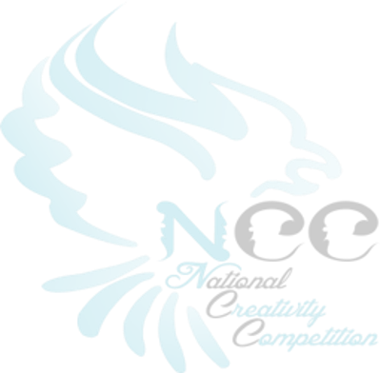
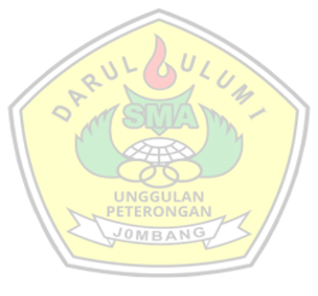

NCC 13th (National Creativity Competition) 2026-2027 |38

Lampiran contoh orisinalitas karya

LEMBAR PERNYATAAN ORISINALITAS KARYA
yang bertanda tangan di bawah ini:
Nama :
Tempat Dan Tanggal Lahir :
Alamat Tempat Tinggal :
No. HP :
Judul :

Dengan ini saya menyatakan bahwa naskah speech yang saya sertakan dalam lomba “NCC 13th (National Creativity Competition) di tahun 2026-2027” adalah benar-benar hasil karya saya sendiri. Bukan jiplakan karya orang lain dan belum pernah diikutsertakan dalam segala bentuk perlombaan serta belum pernah di muat di manapun.
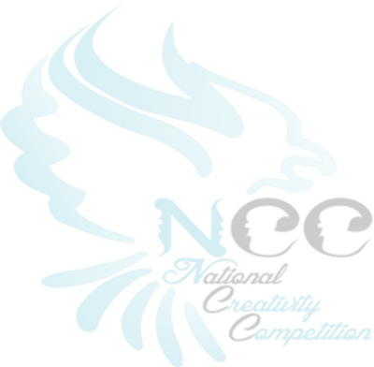
Apabila di kemudian hari karya naskah speech saya tidak sesuai dengan pernyataan ini, maka secara otomatis naskah speech saya dianggap gugur. Demikian pernyataan ini dibuat dengan sebenarnya.
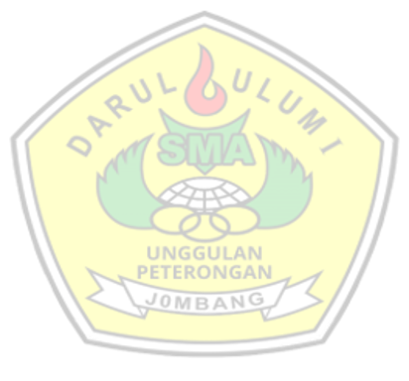
Nama Kota, 2026

Guru Pembimbing  (Nama dan Gelar)  NIP. | 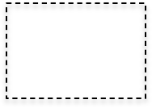  Peserta  materai  (Nama Lengkap)  NISN.
Mengetahui,
Kepala Sekolah

(Nama dan Gelar)
NIP.
.

NCC 13th (National Creativity Competition) 2026-2027 |39

